## Ready, Set, Go!

## Ready

Topic: Rates of change in linear models

© 2012 [www.flickr.com/photos/](http://www.flickr.com/photos/) 401(K) 2012

**Which situation has the greatest rate of change?**

1. The amount of stretch in a short bungee cord or the amount of stretch in a slinky when each is pulled by a 3 pound weight.

2. A sunflower that grows 2 inches every day or an amaryllis that grows 18 inches in one week.

3. Pumping 25 gallons of gas into a truck in 3 minutes or filling a bathtub with 40 gallons of water in 5 minutes.

4. Riding a bike 10 miles in 1 hour or jogging 3 miles in 24 minutes.

## Set

Topic: linear rates of change

**Determine the rate of change in each table below.**

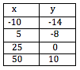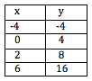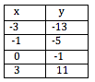5. 6. 7.

## Go

Topic: Graphing linear equations in slope-intercept form.

Graph the following equations:

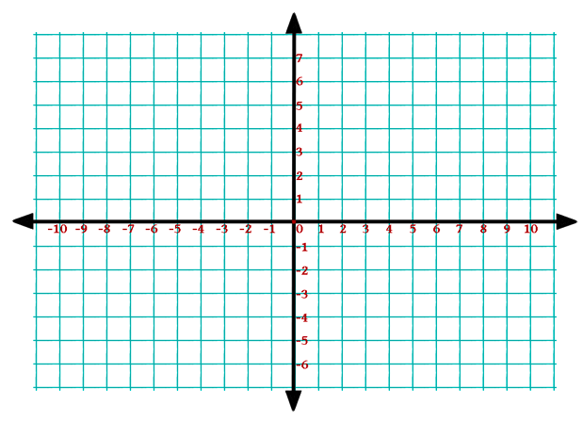8. y = 3x – 1 9. y = -5x + 4

10. y = x 11. y = -4

12. y = ½x – 6 13. x = 3

Need Help? Check out these related videos:

<http://www.algebra-class.com/rate-of-change.html>

<http://www.khanacademy.org/math/algebra/linear-equations-and-inequalitie/v/graphs-using-slope-intercept-form>